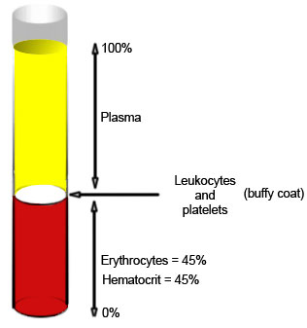
3276CARDIO-RESPIRATORY EXERCISE PHYSIOLOGY WORKBOOK

The Circulatory System

Blood Composition
- Plasma makes up approximately ______ of blood volume
- Cells and platelets make up approximately ______ of blood volume
  - ______ Platelets
  - ______ Red Blood Cells (RBC)
  - ______ White Blood Cells (WBC)

Blood Function
Match the statements.
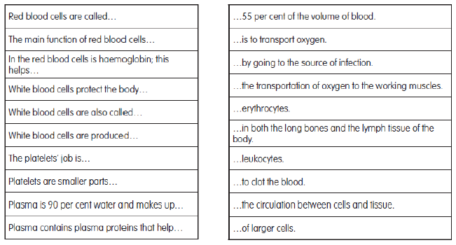

Circulation and the Heart

Blood Vessels
Arteries: Thick, muscular vessels that transport _____________________ blood ______________ from the heart. Pass blood to smaller vessels called _________________ and then to __________________ where gas exchange occurs.
Capillaries: Narrow vessels with thin walls, site of __________________ between blood and tissues.
Veins: Less muscular, flexible vessels that carry ___________________ blood ________________ the heart. Contain valves to prevent back flow of blood.

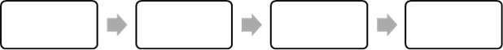
Circulation Pathway

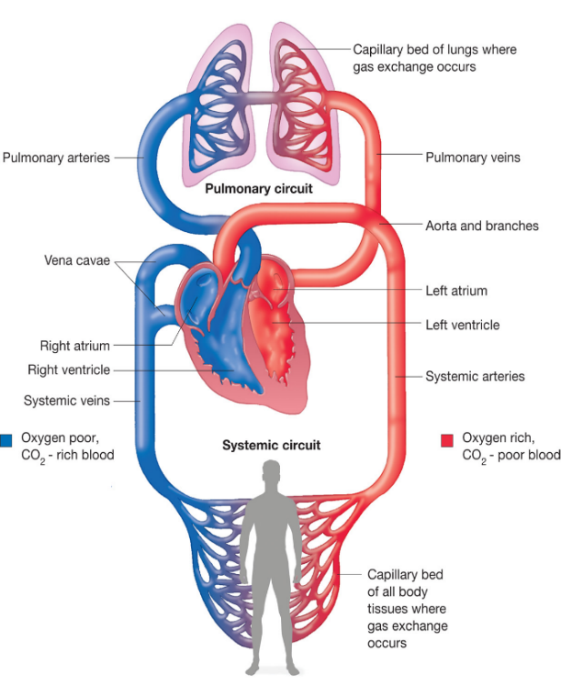
Heart Circulation
Pulmonary Circulation: Delivers ________________ blood from the ___________ side of the heart to the ___________.
Systemic Circulation: Delivers ________________ blood from the ___________ side of the heart to the ___________.

Functions of the Heart
1.
2.
3.

Anatomy of the Heart
Layer | Description | Function
Pericardium
Myocardium
Endocardium

Structure of the Heart
Label the diagram using the terms in your word bank. Colour the path of oxygenated and deoxygenated blood.
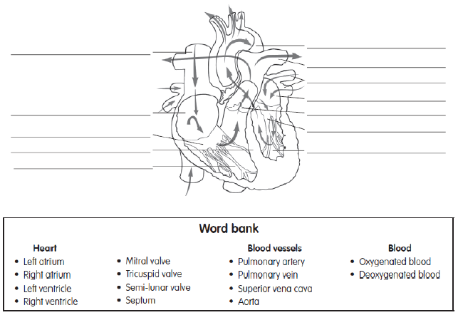

Function of the Heart

Cardiac Impulses
Define the following terms:
Term | Definition / Function
Sinoatrial Node (SA Node)
Atrioventrical Node (AV Node)
Purkinje Fibres
Cardiac Cycle
Diastole
Systole

Cardiac Cycle
The cardiac cycle can be described as the sequence of events that make up one heartbeat.
Describe what takes place during diastole and both atrial and ventricular systole. Be sure to mention whether the different chambers of the heart are relaxed or contracted and what is occurring with the different valves of the heart.
Diastole
Systole
Atrial Systole | Ventricular Systole

Factors Affecting Heart Rate
Heart contraction is affected by hormones and the nervous system.
Parasympathetic Nervous System (PNS): brings the body systems to rest (REST and DIGEST).
Sympathetic Nervous System (SNS): prepares the body for action (FIGHT or FLIGHT).
During exercise the ______ releases __________________ onto the __________________ which increases HR. During recovery the ______ sends impulses down the __________________, which slows the heart rate and brings the body back to rest.

Use your prior knowledge about the ventilator system to complete the phrases below.
Increased rate of…
As a result, CO₂ levels in blood…
This change is detected by…
The medulla oblongata sends a signal to secrete the hormone…
The effect of this hormone is to…
As a result the CO₂ levels in the blood…
This is again detected by…
The PNS sends a signal down the…
Eventually the heart rate will…

Sounds of the Heart and Blood Distribution
Describe the action that matches each of the heart sounds and record your heart rate as measured with a stethoscope
“Lub” ____________________________________________________________________________________________
“Dub” ____________________________________________________________________________________________
Heart Rate according to the stethoscope: ______________
Fill in the graph with the changes in blood distribution at rest vs. during exercise. Provide an explanation.

Explanation:________________________________________________________________________________________

__________________________________________________________________________________________________

Blood Pressure
Resting, healthy adult range for blood pressure is generally ______ mmHg (systolic) to ______ mmHg (diastolic) and is read as “______ over ______ mmHg”
- Low blood pressure: 90-100 / 50-60 mmHg
- High blood pressure: 140/100 mmHg

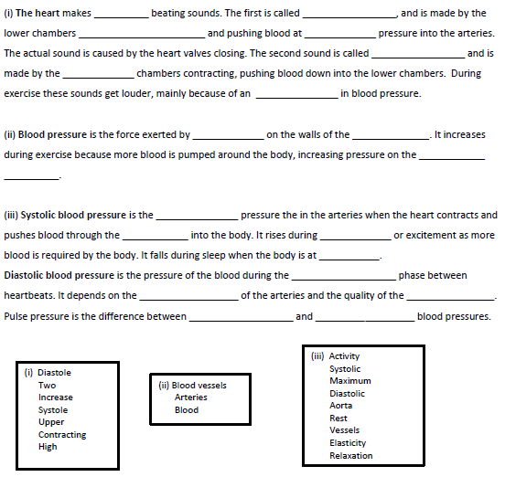
Complete the paragraphs below using the terms from the word banks provided.

To Do: Green box pg. 41
What is your blood pressure?
Answer questions #1-5

Cardiac Output
Define the following important terms
Term | Definition | Unit | Symbol
Pulmonary Circulation |  | --- | ---
Systemic Circulation |  | --- | ---
Cardiac Output
Stroke Volume
Cardiac Output (Q) = (Stroke Volume x Heart Rate) / 1000
