Metabolism

3.2.1 Outline metabolism, anabolism, aerobic catabolism and anaerobic catabolism.
Metabolism: _______________________________________________________________________________________ __________________________________________________________________________________________________
Anabolism: ________________________________________________________________________________________ __________________________________________________________________________________________________
Catabolism: ________________________________________________________________________________________ ____________________________________________________________________________________________________________________________________________________________________________________________________

3.2.2 State what glycogen is and its major storage sites.

Carbohydrate Metabolism
Glucose is broken down to provide energy in a process known as ________________________. Glucose that is not used is stored as _______________________. The conversion of glucose to glycogen is called __________________________. When the energy stored in the glycogen is needed it is turned back into glucose. This process is known as _________________________ (the conversion of glycogen to glucose).

Test Yourself
Read pages 63 and 64 in your textbook and draw your own diagram to show the relationship between the following:

- Liver
- Muscle
- Blood stream
- Food
- Glucose
- Glycogen
- Lactate
- CO₂
- Water
- Glycolysis
- Glycogenolysis
- Glycogenesis

3.2.3 State the major sites of triglyceride storage.

Fat Metabolism
The energy yielding process in fat metabolism is the ____________________________ of fatty acids. B-oxydation occurs in the ___________________________ to which fatty acids are transported. Fatty acids are generally broken down to ________________________ molecules by shortening the ________________________. This involves a series of reactions that reduce the fatty acid chain by ______ carbons at a time. More energy is released when acetyl CoA is further metabolized in the ___________________________.
Eating more fat than the body requires leads to excess fat being stored as __________________________ in adipose tissue (fat) and skeletal muscles. ____________________________ is the process of releasing stored fat from the body’s reserves so it can be used as energy when the body is in short supply.

3.2.4 Explain the role of insulin in the formation of glycogen and the accumulation of body fat.
What is the function of insulin in the body? ______________________________________________________________ _________________________________________________________________________________________________. Insulin is produced by ______________________________ and secreted by the ________________________________.

After Eating
Glucose concentration in the blood _______________. This signals the pancreas to secrete _______________. Insulin increases _________________________________________ (especially liver and muscle cells). Fast uptake of glucose in the blood stops the release of glucose from the ____________ and _________________ stores and promotes the synthesis of _______________________.

Other Functions of Insulin
- Stimulates glycolysis – to signal ______________________________________ to all organs.
- Inhibits gluconeogenesis – the conversion of _________________ or __________ into glucose.
- Promotes glycogensis – the conversion of __________________ to ___________________.
- Inhibits ________________ in fat stores and the breakdown of proteins.
- Promotes the synthesis of proteins.
- Promotes the storage of triglycerides (fat stores).

After Fasting
When blood glucose decreases after a period of __________________ or __________________ the hormone glucagon is secreted. Glucagon acts in _________________ to insulin stimulating ________________ and the synthesis of glucose which increases glucose levels in the ___________. Glucagon also activates __________________ of triglycerides in fat stores which adds to the energy supply.

Insulin and Fat Accumulation
Receptors in the _______________ are sensitive to changes in _________________ level, thus releasing the necessary requirements of ________________ and ________________ depending on the needs of the body. A diet high in sugar and fat will result in a ___________________ release of insulin and consequently an increase in ___________________ storage and accumulation of _________.

3.2.5 Outline the terms glycogenolysis and lipolysis.
Glycogenolysis: _____________________________________________________________________________________ __________________________________________________________________________________________________ __________________________________________________________________________________________________
Lypolisis: __________________________________________________________________________________________ __________________________________________________________________________________________________ __________________________________________________________________________________________________

3.2.6 Outline the functions of glucagon and adrenaline during fasting and exercise.
- During fasting blood glucose levels drop because ___________________________________________________.
- During exercise blood glucose levels drop because __________________________________________________.
- This results in the release of the hormones _________________________ and ___________________________.
Glucagon and adrenaline both _________________________________________________________________________ In addition, adrenaline (epinephrine) stimulates the breakdown of ___________________________________, which is not released into the blood but rather __________________________________________________________________.
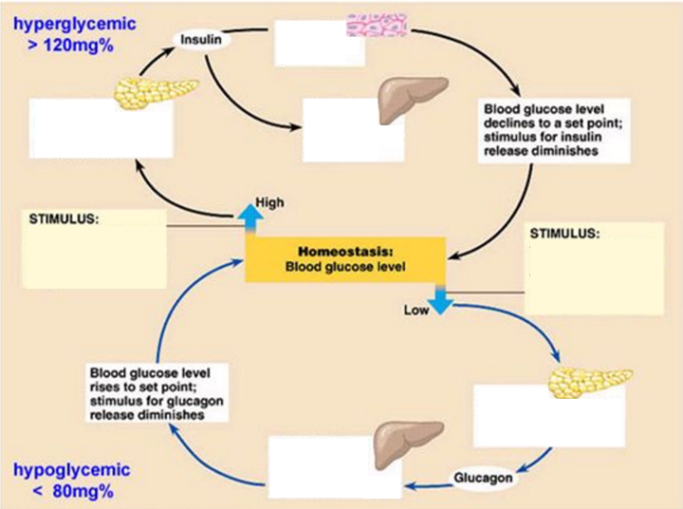

3.2.7 Explain the role of insulin and muscle contraction on glucose uptake during exercise.
Summarize the paragraph “muscle glucose uptake during exercise” using the space below.
Initial energy supply: _________________________________________________________________________________ ____________________________________________________________________________________________________________________________________________________________________________________________________
Accessing stored glucose: _____________________________________________________________________________ ____________________________________________________________________________________________________________________________________________________________________________________________________
Maintaining energy supply: ___________________________________________________________________________ ____________________________________________________________________________________________________________________________________________________________________________________________________

Energy Systems

3.3.1 Draw a diagram to show the ultrastructure of a generalized animal cell
Label the following: ribosomes, rough endoplasmic reticulum, lysosomes, Golgi apparatus, mitochondrion and nucleus.
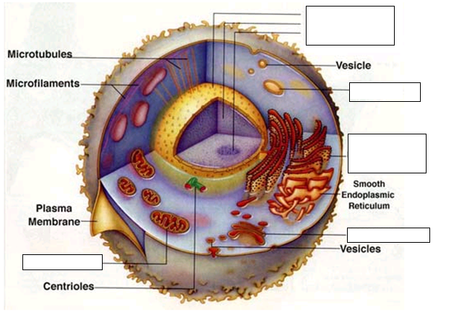
Structure | Description
Nucleus
Ribosomes
Endoplasmic Reticulum
Golgi Apparatus
Lysosome
Mitochondrion

3.3.2 Annotate a diagram to show the ultrastructure of a mitochondrion
Label and describe the following structures: cristae, inner matrix, and outer smooth membrane.

Main Function of Mitochondrion:
___________________________________________
___________________________________________
___________________________________________
___________________________________________
___________________________________________

Structure | Description
Cristae
Inner Matrix
Inner Membrane
Outer Smooth Membrane

3.3.3 Define the term cell respiration
Cell respiration is: ___________________________________________________________________________________ ____________________________________________________________________________________________________________________________________________________________________________________________________
Breakdown of: Energy Currency: Biochemical Processes:

Cellular Respiration can be divided into three metabolic processes each of which occurs in a specific region of the cell:
- Glycolysis occurs in the ________________________________________________________________________
- The Krebs Cycle takes place in the _______________________________________________________________
- Oxidative Phosphorylation (ETC) is carried out on the _______________________________________________

3.3.4 Explain how adenosine can gain and lose a phosphate molecule
ATP, adenosine triphosphate, is an energy rich chemical compound which serves as the immediate source of energy for most of the reactions in the body. ATP is often referred to as the energy currency of the cell.
Chemical makeup of ATP: Explain how ATP works:
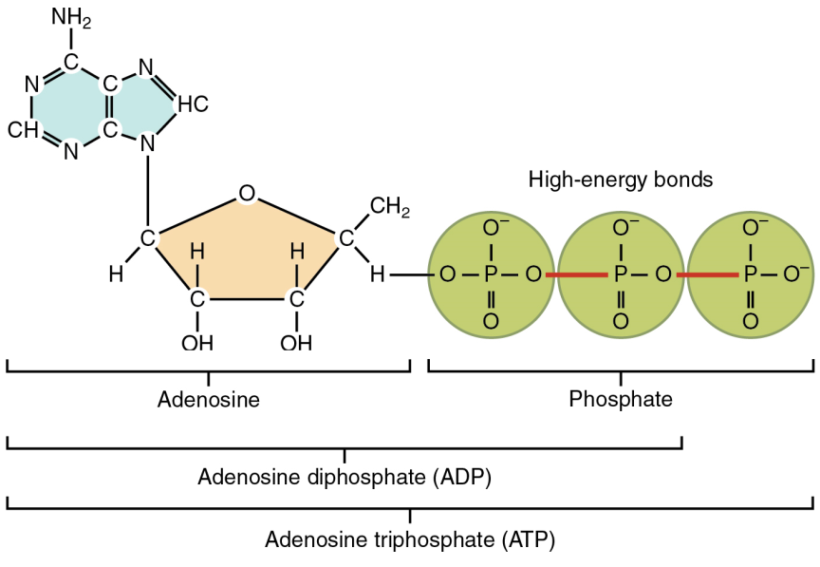
_____________________________________________
_____________________________________________
_____________________________________________
_____________________________________________
_____________________________________________
_____________________________________________
_____________________________________________
_____________________________________________
_____________________________________________

ATP + H2O = ADP + Pi + Energy

3.3.5 Explain the role of ATP in muscle contraction

ATP in Muscle Contraction
- All muscle fibers have the capacity to produce ATP using ________________________ and ___________.
- The release of energy from ____________________________________ provides energy for muscle contraction.
- In the muscle, there is enough ATP present to allow for __________________ of muscle activity.
- Any activity lasting longer must use ATP from other sources called ____________________________.
- These systems main function is to _______________________________ so they greatly influence our ability to perform different types of exercise.

The 3 Energy Systems
System | Description | Rate of ATP Production | Total Ability to Produce ATP | Fuels Used
Phosphogen
Anaerobic
Aerobic

3.3.6 Describe the re-synthesis of ATP by the ATP-PC system.
- ________________________ (a high energy molecule) is broken down by the enzyme _____________________ to provide energy for the re-synthesis of ATP that has been used during initial stages of exercise.
- Creatine kinase breaks down creatine phosphate (CP) by _____________________________________________ and transfers it to __________ to form ___________.
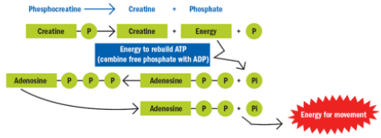

3.3.7 Describe the production of ATP by the lactic acid system
- The lactic acid system is also known as _________________________________ (meaning without oxygen).
- Glycolysis releases some of the energy in glucose as ATP and produces pyruvate.
- When oxygen is not available pyruvate is then converted into ______________________, which limits the amount of ATP produced to _______________________.
- Lactic acid ______________________ within the muscle which reduces the muscle _________. This causes discomfort and also reduces the ability of muscle to contract and we begin to slow down.
No O₂
Glucose -----------------> Pyruvate -----------------> Lactate
Uses 2 ATP Gives 4 ATP = 2 Net ATP

3.3.9 Describe the production of ATP from glucose and fatty acids by the aerobic system
- In the presence of oxygen __________________ is converted to ________________________ and is processed by the _______________________ producing 2 ATP and liberating electrons that are then passed through the __________________________________________ which produces 34 ATP.
- ______________________________ are transformed into Acetyl Co A that enters the Krebs Cycle (needs O₂)
O₂ Present Needs O₂ Needs O₂
Glucose -------> Pyruvate -------> Acetyl CoA -------> Krebs Cycle-------> Electron Transport Chain
Gives 2 ATP Gives 34 ATP

3.3.10 Discuss the characteristics of the three energy systems and their relative contributions during exercise.
Summarize, in your own words, the relative contributions of the three energy systems during high intensity exercise:
__________________________________________________________________________________________________
__________________________________________________________________________________________________
__________________________________________________________________________________________________
__________________________________________________________________________________________________
__________________________________________________________________________________________________
__________________________________________________________________________________________________
__________________________________________________________________________________________________
__________________________________________________________________________________________________
__________________________________________________________________________________________________
 | Phosphagen System | Lactic Acid System | Aerobic System
Primary fuel source
Duration of activity
Bi-Products
Sport Examples
Intensity
ATP Produced
Speed ATP Produced
Advantages
Disadvantages

3.3.8 Explain the phenomena of oxygen deficit and oxygen debt
Oxygen Deficit: _____________________________________________________________________________________
__________________________________________________________________________________________________
__________________________________________________________________________________________________
Oxygen Debt (EPOC): ________________________________________________________________________________
__________________________________________________________________________________________________
__________________________________________________________________________________________________
