Heart Worksheet

1. The diagram below shows an external view of the heart.
Show the positions of the following structures on the diagram.
Right atrium, left atrium, right ventricle, left ventricle, aorta, inferior vena cava,
Pulmonary artery, coronary artery, superior vena cava.
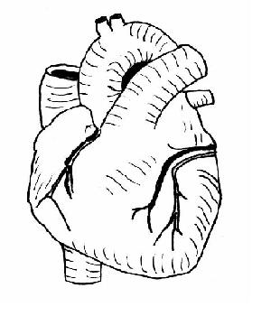

2. The diagram below shows a section through the heart seen from the same direction as the external view in question 1.
a) Label the following structures:
right atrium, left atrium, right ventricle, left ventricles, inferior vena cava, superior vena cava, aorta, pulmonary artery, pulmonary vein, tricuspid valve, bicuspid (mitral) valve, pulmonary valve, aortic valve
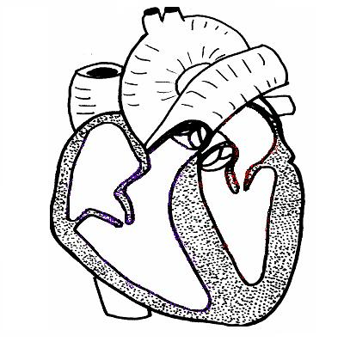
b) On the diagram of the heart shown above indicate the direction of blood flow through the heart. Use red to show the pathway of oxygen-rich blood and blue the pathway of oxygen-poor blood.

3. Choose terms from the list to complete the sentences below.
atria; right hand side; vena cava; ventricles; valves; pulmonary artery; veins; arteries; left hand side; aorta, coronary artery;
- The top two chambers of the heart are called _______________
- These structures stop blood flowing backwards into the atria. _______________
- This side of the heart receives oxygenated blood. _______________
- This is the largest artery in the body. _______________
- These are blood vessels that carry blood towards the heart. _______________
- This blood vessel supplies the heart with oxygenated blood? _______________
4. Fill in the name of the blood vessel in the table below.
Name of blood vessel | Blood? | Walls? | Towards or away from heart
 | Oxygenated | Thin | Towards
 | Oxygenated | Thick | Away from
 | Deoxygenated | Thick | Away from
 | Deoxygenated | Thin | Towards
5. Arrange these events in the correct order starting with F.
A. The left ventricle contracts and blood flows along the aorta to the body
B. The blood flows through the tricuspid valve into the right ventricle.
C. Oxygenated blood flows along the pulmonary veins into the left atrium
D. The blood passes through the mitral valve into the left ventricle
E. The left atrium contracts
F. Deoxygenated blood flows from the inferior and superior vena cava into the right atrium.
G. The deoxygenated blood picks up oxygen
H. The right atrium contracts
I. The right ventricle contracts and blood flows along the pulmonary artery to the lungs

