IA Data Collection and Processing Template (DCP)
- Explain any changes in procedure or unusual conditions, if any.

Example) only 4 trials instead of 5 were run due to lack of time.

- Record all relevant raw data, data you have obtained from the experiment, in an organized data table.
Sample

Table 1.1:
Raw data table to show the age, gender, body mass, height, thigh circumference, reach height and jump height for each participant.
Participant No. | Gender | Age | Body Mass  (kg ± 0.5) | Height (cm ± 0.5) | Thigh Circumference (cm ± 0.5) | Reach Height (cm ± 0.5) | Jump Height (cm ± 0.5)
1 | Female | 17 | 53.0 | 167.4 | 44.0 | 214.5 | 250.5
2 | Female | 17 | 44.5 | 158.5 | 39.5 | 197.5 | 229.5
3 | Male | 17 | 64.5 | 169.3 | 42.0 | 214.0 | 249.5
4 | Female | 15 | 57.0 | 166.4 | 44.0 | 205.0 | 247.5
5 | Female | 16 | 55.0 | 164.5 | 40.5 | 207.5 | 245.0

Data Table Title and Description- A summary of what was done to obtain the data in the table

Data Table- Record all quantitative data, measurement including units, to the same number of decimal places equal to the uncertainty of the instrument used.

Record all necessary qualitative data (non-numerical, descriptive data)

- Processing Data- Statistical analysis of the quantitative data
Sample

Table 2.1
Processed data table to show the age, gender, height jumped (net height), and leg power for each participant.
Participant No. | Net Height (cm ± 0.5) | Leg Power (kg m/sec ± 2.0)
1 | 36.0 | 70.0
2 | 32.0 | 57.0
3 | 35.5 | 84.0
4 | 42.5 | 83.0
5 | 37.5 | 75.0

Calculations
Net Height:
Jump Height (cm ± 0.5) – Reach Height (cm ± 0.5)
E.g. Participant 1: 250.5 cm – 214.5 cm = 36.0 cm
E.g. Participant 2: 249.5 cm – 214.0 cm = 35.5 cm

Calculate mean (average) of the data – SHOW WORK AND FORMULA!

Standard Deviation (use calculator and/or computer program to compute) – SHOW FORMULA!

Other Calculations required for properly interpreting the data - SHOW WORK AND FORMULA!
Eg) frequency table (median/mode), percentage, percent change, rate, t-test, R² value, etc.

- Present Manipulated Data- DO NOT graph raw data, only the data you obtained by the calculations
Graph 1.1:
A scatter graph to show the relationship between a participant’s thigh circumference (cm) and leg power (kg m/sec).
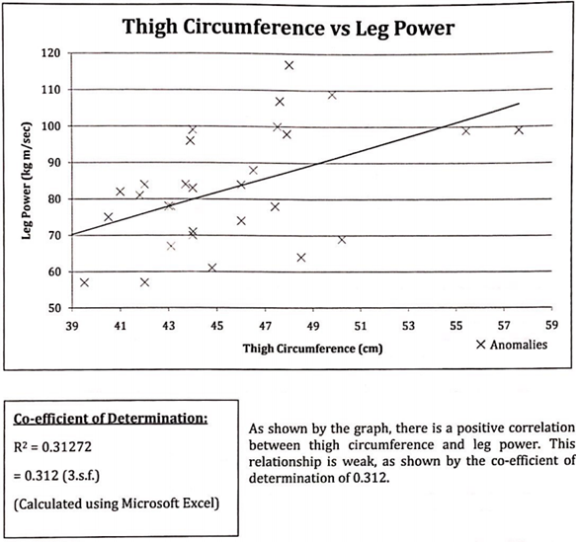

Identify the best way to present your manipulated data and explain why. Example) line graph, pie graph, bar chart, etc.

Title for Graph/Chart- Should be 1 to 2 sentence description of what the graph is showing

Graph

What is the label for the x-axis? (this is the independent variable with units and uncertainty of measure.

What is the label for the y-axis? (this is the dependent variable with units and uncertainty of measure.

If graphing more than one piece of data on the graph, provide a legend or a key for the data.

If representing data with a line graph, draw the line/curve of best fit. State the formula for the “line of best fit and or correlation coefficient.”

***If representing data with a bar chart or line graph, add error bars, a representative of one standard deviation from the mean.

