Anatomy Basics Workbook

Draw the anatomical starting position

Define each of the following key terms

- Superior: ___________________________________________________________________________

- Inferior: ___________________________________________________________________________

- Anterior (ventral): _____________________________________________________________________
- Posterior (dorsal): _____________________________________________________________________

- Medial: ___________________________________________________________________________
- Lateral: ___________________________________________________________________________

- Proximal: ___________________________________________________________________________

- Distal: ___________________________________________________________________________
- Internal: ____________________________________________________________________________
- External: ___________________________________________________________________________

Planes of Motion

What is a plane of motion? ____________________________________________________

Define each:

- Sagittal plane _____________________________________________________________

- Frontal plane ______________________________________________________________

- Transverse plane ___________________________________________________________

Anatomical Axes

What is an axis of the body?

Define each:

- Frontal (horizontal) axis ____________________________________________________

- Sagittal (Antereoposterior) axis ________________________________________

- Longitudinal axis _____________________________________________________

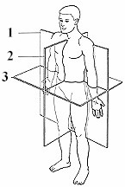
Label the following: planes of motion & axes of rotation

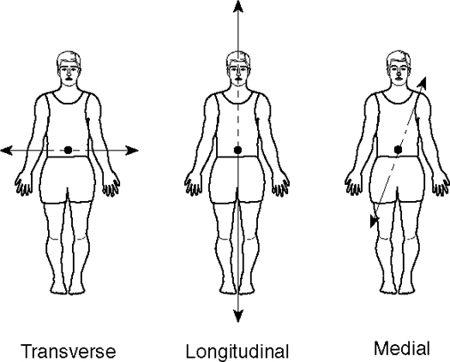
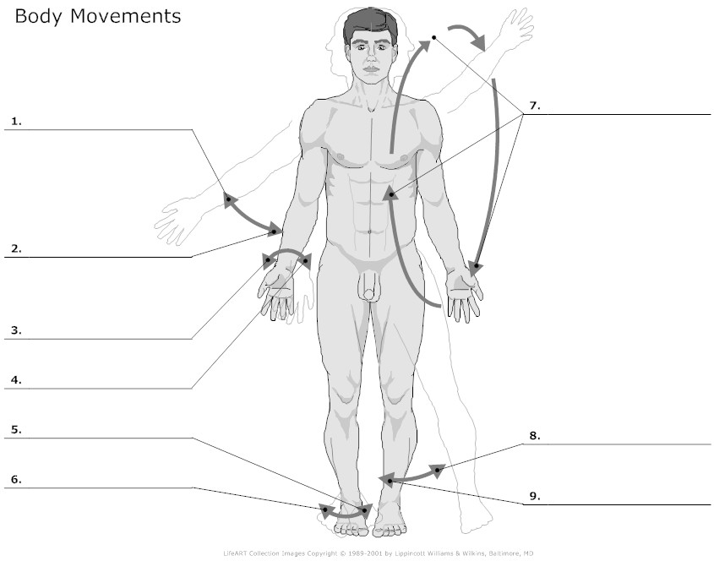

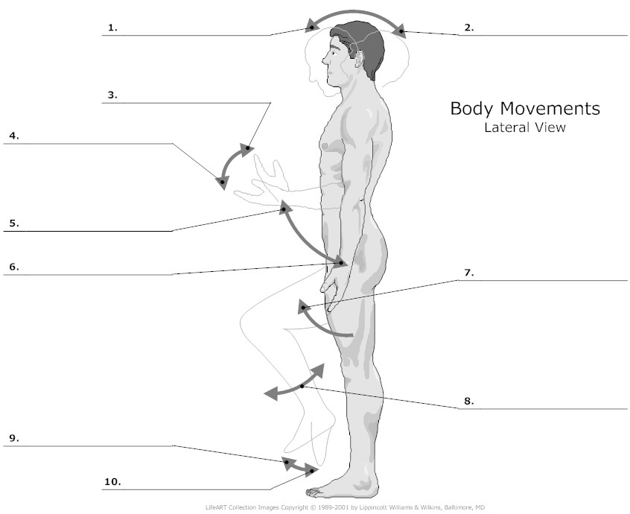

The skeletal system

Annotate the functions of the skeleton on the diagram below

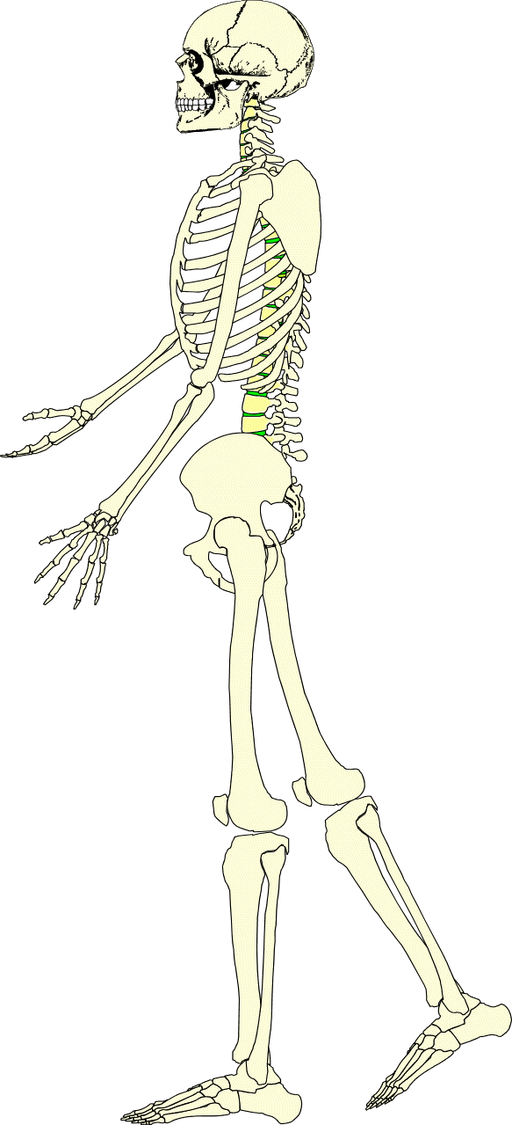

List the different parts of the skeletal system

Label the skeleton in the diagram below – also indicate the axial skeleton and appendicular skeleton using two different colours.
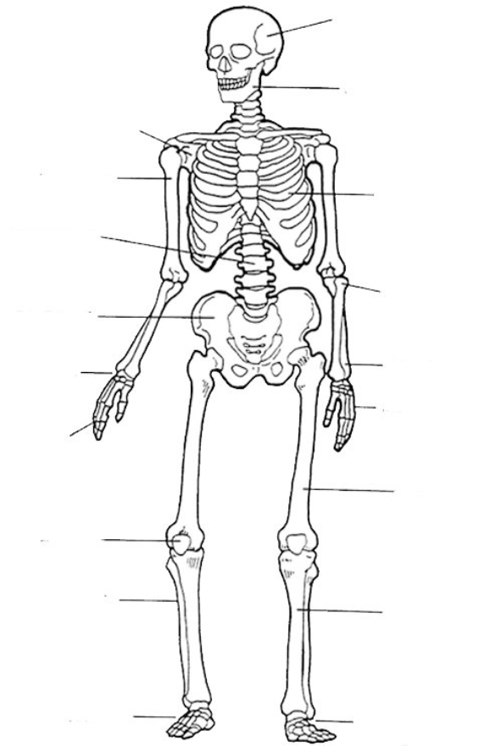
Label the vertebral column in the diagram below

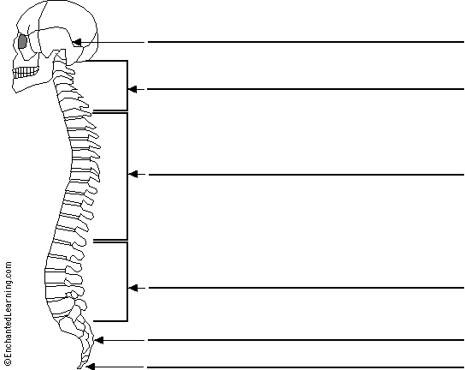

State the functions of the vertebral column

Describe the shape of the vertebral column (use diagrams if needed).

Label the diagram of the skull below

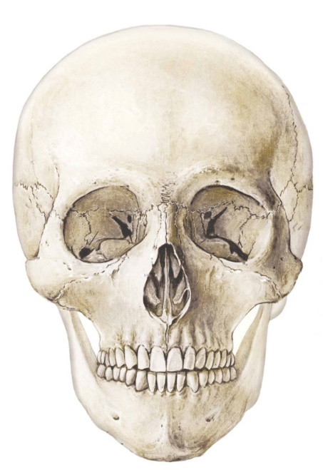

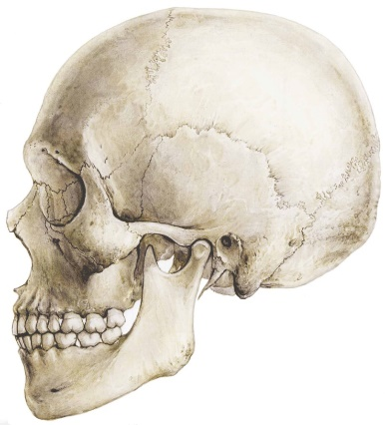

Label the diagram of the thoracic cage below

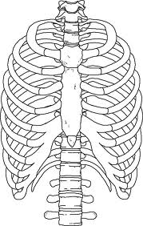

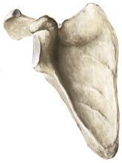
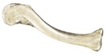
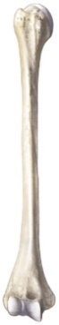
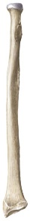
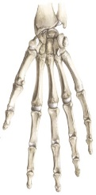
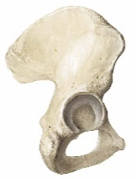
List and Label the components of the:
- Pectoral Girdle
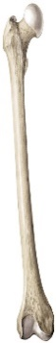
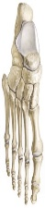

- Upper Limb

- Pelvic Girdle

- Lower Limb

Complete the table below to describe the four different types of bone

Type of bone | Description | Example
Have a long cylindrical shaft
Enlarged at both ends
Length greater than width
Provide levers for movement

Small and cube shaped
Usually articulate with more than one other bone
Good shock absorbers
Curved surfaces
Vary from thick to very thin
Provide protection
Broad surface provides large area for muscle attachment
Cannot be placed in groups
Have specialised shapes for their function
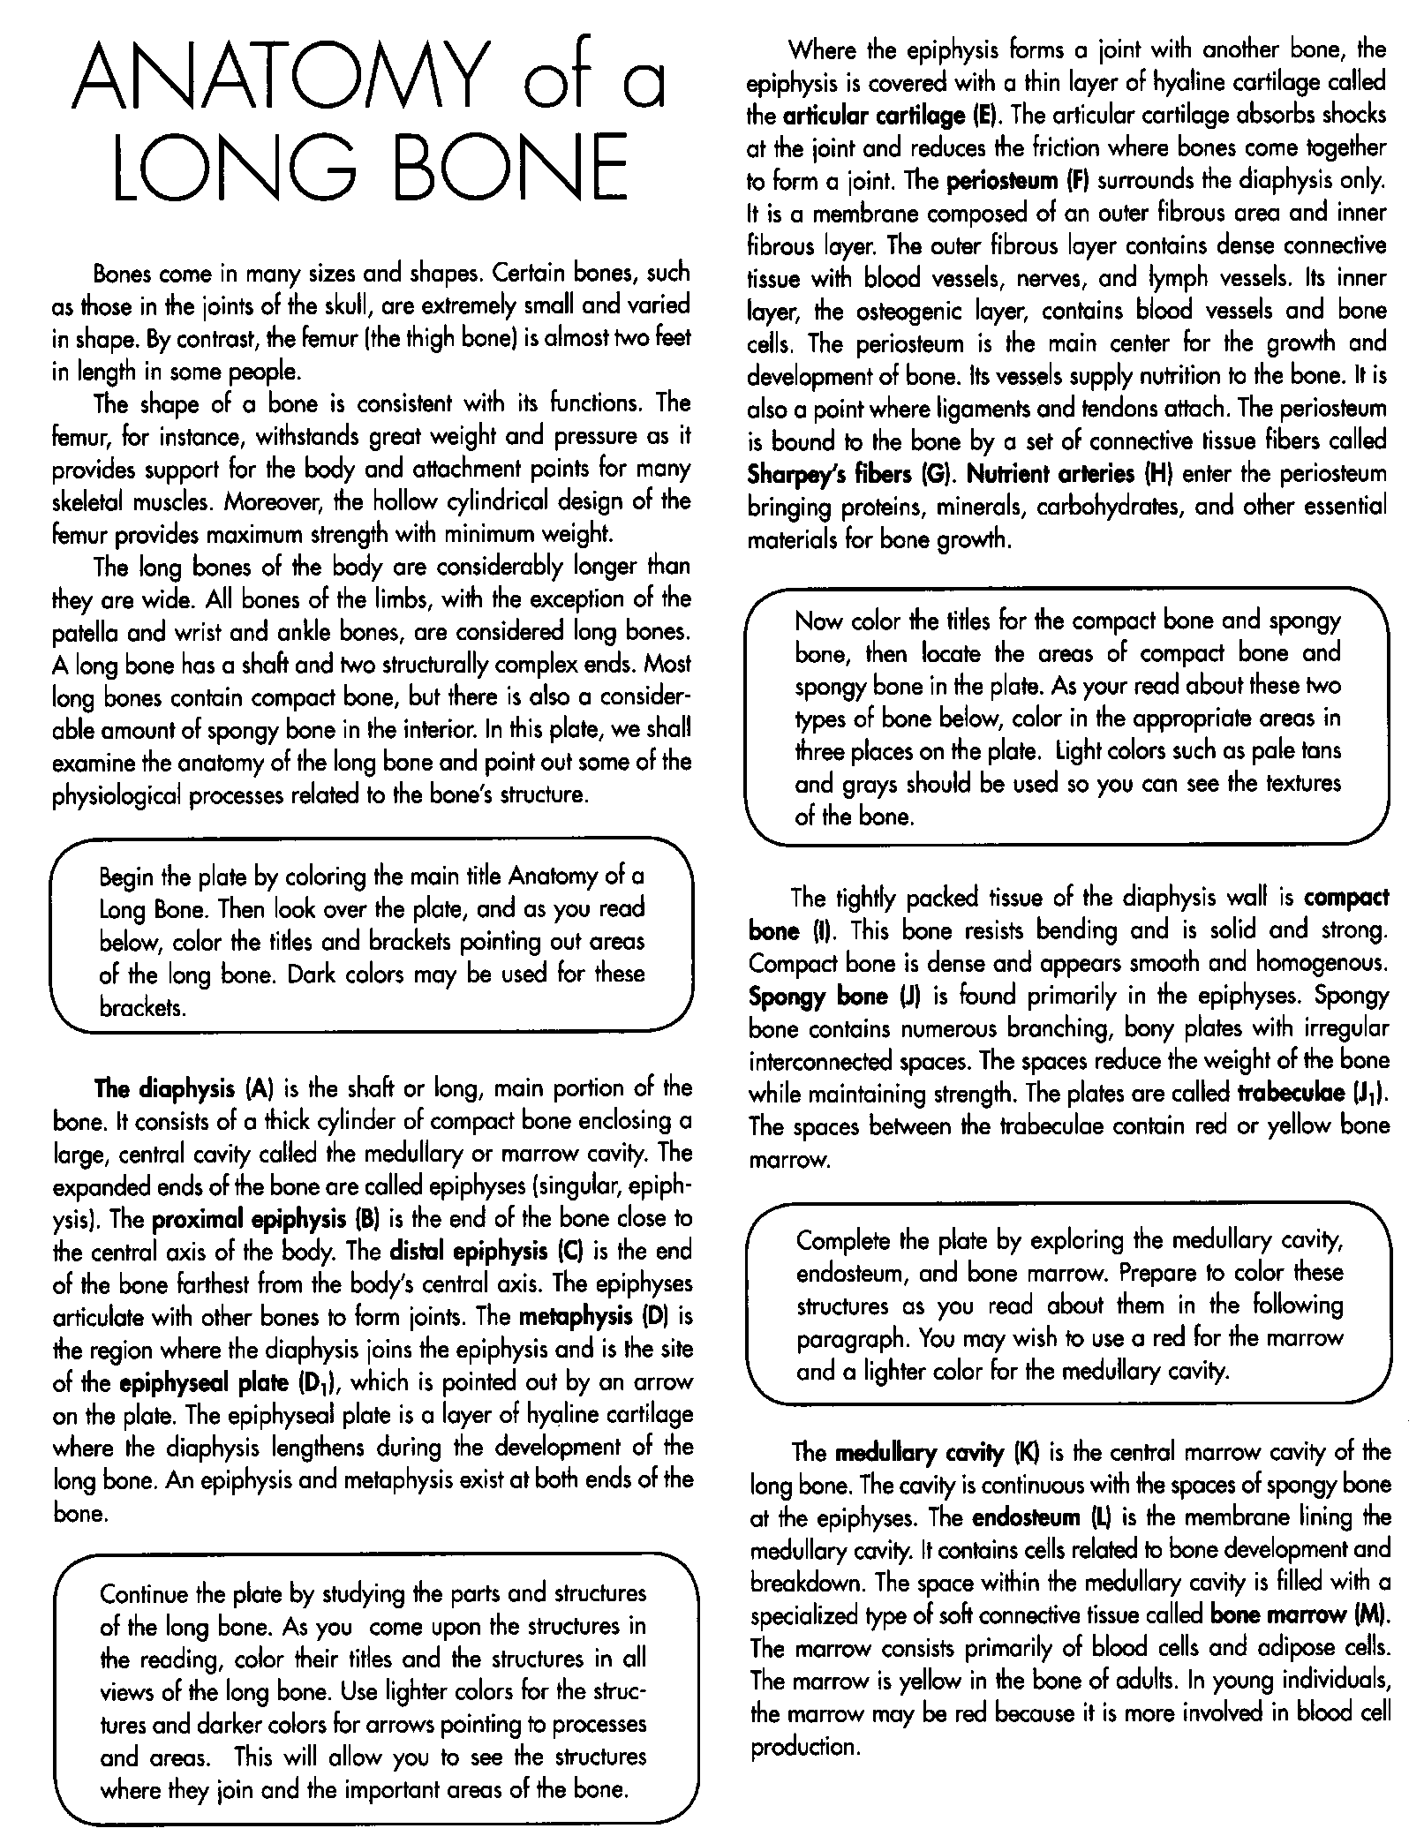

The Anatomy of Long Bone Coloring

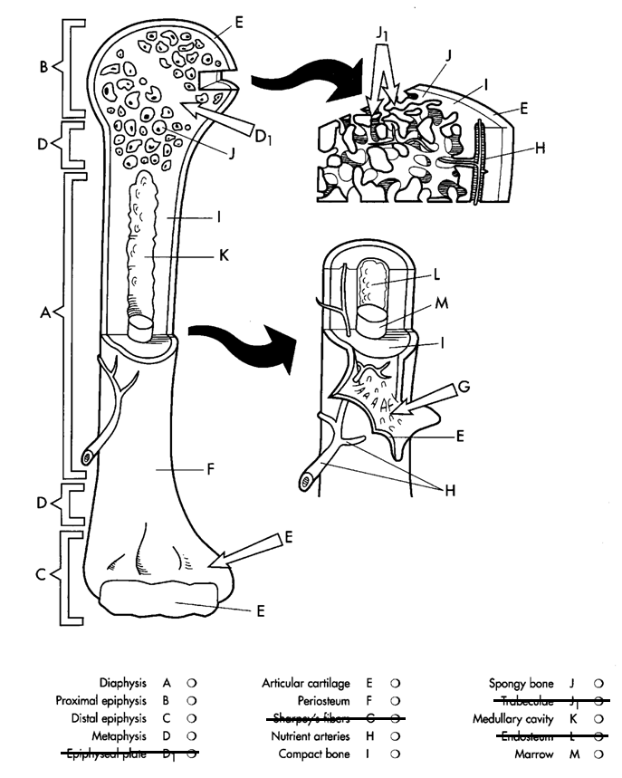

List and Explain the composition of bone.
_____________________ – calcium carbonate and calcium phosphate
- Make up _____________ of bone’s weight
- Provide much of the bone’s ________________ and resistance to pressing or squeezing forces.
_____________________ – a protein
- Gives bone its characteristic ___________________ and contributes to its ability to resist pulling and stretching forces.
- With age collagen is lost progressively and bone becomes more __________________.
_____________________
- Bone consists of much smaller proportion of water than other body parts

Compact Bone vs. Spongy (cancellous) Bone
 | Cancellous bone | Compact Bone
- Porosity | - High (Low __________ content and high collagen) | - Low (High mineral content and low ___________)
- Structure
- Characteristic | - Provides more _________ but is not as __________ resistant | - __________ and can resist greater stress but less ___________
- Function | - Shock absorption due to its better ability to change shape are important | - Withstanding stress in body areas that are subject to higher impact loads
- Location | - e.g., vertebrae, ends of long bones. | - Long bones (e.g., bones of the arms and legs)

CASE STUDY - Bone as a dynamic tissue

Bone is a dynamic tissue that means it is constantly changing in response to activity levels or disuse. Bone cells are continually broken down and removed through a process called resorption and these cells are then replaced with new cells during bone deposition. If the amount of bone that is deposited equals the amount that is resorbed, then the bone mass remains constant. An increase in bone mass results in increased strength while decreased bone mass is associated with decreases in strength.

Bone can alter its structure or properties if there is a change to the mechanical stress placed on it. The main types of mechanical stress are the skeletal muscles pulling on the bones and the effects of gravity. According to Wolff’s Law, bone in a healthy person or animal will adapt to the load it is placed under. This means that if a bone is exposed to a greater load, for example through training, there will be increased mineral salt deposits and greater production of collagen fibres to increase bone strength and the ability to resist this load. Athletes who repeatedly apply high stresses to the bones have noticeably higher bone mineral density and stronger bones compared to non-athletes.

In contrast, those who are sick and confined to bed, those who break a leg and are n crutches, or astronauts who are on space missions all experience restricted weight bearing activity. This results in too much bone resorption and not enough bone deposition and result in losses of up to 1% of bone mass per week as well as decreases in bone strength.

Questions

- What precautions would an astronaut have to take immediately after returning to earth?

- Identify a sport that would increase bone density in the lower limbs and explain why it would do so

- Identify a sport that would increase bone density in the upper limbs and explain why it would do so

- Can you think of any sports where bone mass or bone mineral density might be higher in one limb compared to the same limb on the opposite side of the bod? Why would this happen?

ToK in SEHS (extract taken from the following BBC News article)

Ballet and eating disorders: 'Unspoken competitiveness' adds pressure to be thin
28 June 2013
By Sandish Shoker
BBC News, Nottingham

Rachel Parker, 43, speaks at conferences for Dance UK about dancers and eating disorders.

The ex-Birmingham Royal Ballet dancer was never medically diagnosed as having anorexia but was forced to change her diet when she was diagnosed with osteoporosis in her 20s.

"I never had any issues with my body or image when I was younger. I was always quite a small build so there was never a lot of pressure to be thin," she said.

"My problems started after a tour to Taiwan. I got very ill and lost a lot of weight so when I came back to work I was expecting concern about my appearance but instead I got praise on how amazing I looked. I felt I got more attention and I started getting more principal roles.

"I started restricting my diet to keep that body shape and I became obsessed with food. I was just eating enough to get through my training and performances, which looking back was nowhere near enough."

Rachel's condition was recognized by a doctor when she was tested for bone density and was told she had the spine of a 70-year-old caused by years of a poor diet.

"Ballet is always about aesthetic lines and unfortunately you associate this kind of thinness with beauty in the ballet world," she added.

"There are certain types of performers and personalities that fall victim to eating disorders - the perfectionists and highly self-critical people.

"As much as you tell young dancers the dangers and risks of eating disorders many think in the moment and are not looking ahead. They have no idea what they are doing to their body and their life. They don't realize a couple of missed meals is dangerous, and dancers are restricting their diets to stay a certain way, it's just not normal."

