JOINTS WORKBOOK
Key terms
Term | Definition
Joint | - Point of __________________ between two bones.  - The point at which two bones ___________________.
ligament | - Connect __________ to ___________ and help stabilize joints.  - Composed mostly of long, stringy ________________ fibers.  - Slightly elastic so they can be stretched and lengthened to increase flexibility. When overstretched may compromise joint integrity.
Tendon | - Tough and flexible bands of _______________ tissue that attach skeletal __________________ to _____________.
to articulate | - To form a joint

Factors Affecting Joint Stability
- __________________________________________________________________________________________________________________________________________________________
- __________________________________________________________________________________________________________________________________________________________
- __________________________________________________________________________________________________________________________________________________________
- __________________________________________________________________________________________________________________________________________________________
With a partner compare the hip joint and the shoulder joint on the basis of mobility and stability.
When is this an advantage?
When is it a disadvantage?
Types of Joints
Type | Description | Example
Fibrous | - Thin layer of fibrous tissue connecting the ____________ of two bones.  - Continuous with ____________________.  - No movement allowed at these joints.
Cartilaginous | - Bones separated by ____________________ discs or thick layers of __________________ cartilage.  - Limited movement allowed.
Synovial | - Most commonly occurring joint.  - Most important for __________________.

Characteristics of Synovial Joints
- Joint cavity
  - Space ________________ bones
- Synovial membrane
  - _______________ joint cavity, except over the surfaces of the articular cartilage
  - Secretes the lubrication fluid (_____________________)
- Joint Capsule
  - Flexible to allow movement to take place.
  - May or may not have thickenings (intrinsic ligaments) to prevent joint dislocation.
- Ligament
  - Support the joint and connect the __________________________ of the joint
- Tendon
  - Attaches _______________ to bone
- Articular Cartilage
  - Smooth white layer that covers the articulating surface of bones
  - _________________, absorbs shock, and _____________________ bone
- Fibrocartilage – menisci
  - Semi-lunar discs that help bones fit together more __________________
  - Also helps with __________________ and ______________________
- Hyaline cartilage
  - A protective layer of dense _____________________ that covers the ends of the articulating bones

Structure of a Synovial Joint – label and annotate with definitions.

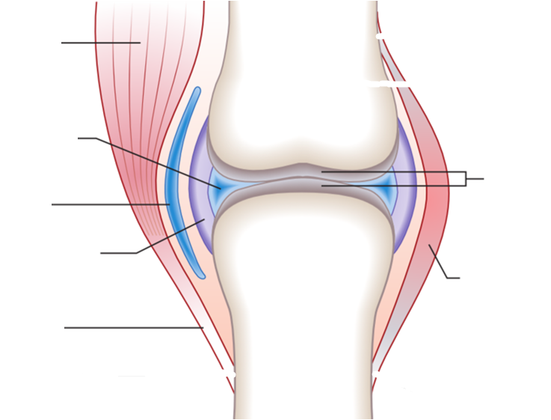

The Bone Song http://www.youtube.com/watch?v=a0E5Nckxu5g
Verse 1
Verse 5
28 _____________ in my fingers and thumbs
And 44 bones already, still not done!
1 coxal – a hip,
1 _____________ - a thigh,
2 _____________ are kneecaps – my, oh my!

Verse 6
_____________ and fibula in each shin,
Tibia’s fat, and _____________ thin!
Each ankle has 7 _____________ bones
Twist them, sprain them, hear them groan!

Verse 7
10 _____________ in the balls of my feet.
28 _____________ in my toes..that’s so neat!
How many bones is that, you ask?
Well, add them them up…..
And complete the task!
206!!!!!!!

14 bones make up my face
The _____________ bones surround an empty space.
No that’s not right, they’re protecting my brain!
Where was I let’s start again.

Verse 2
22 bones under my hair;
3 _____________ in each ear.
The _____________ bone inside my throat.
Who knew that? Let’s make a note!

Verse 3
26 _____________ in my spine,
24 _____________ in this chest of mine,
The _____________ keeps them all apart,
They’re protecting my lungs and my heart.

Verse 4
2 bones in each shoulder, front and back.
3 in each arm, it’s the muscles I lack!
8 _____________ that make up each of my wrists
5 _____________ per palm, how’s our list?

Different Types of Synovial Joints
Joint Type | Movement at joint | Examples | Structure
Hinge |  | 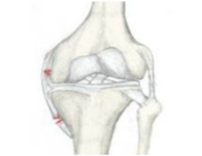  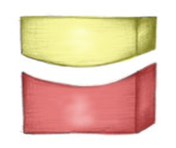  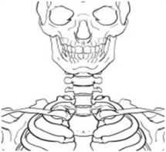  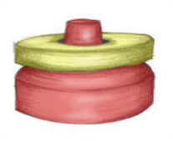  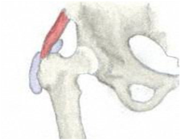  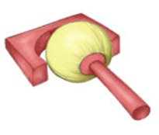  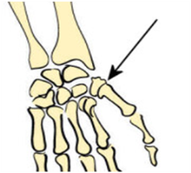  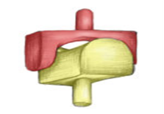  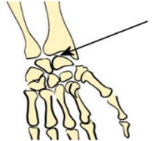  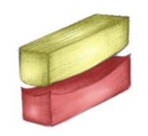  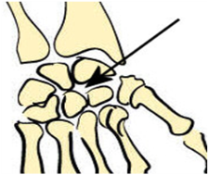  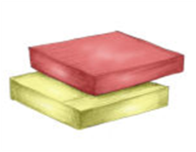
Pivot
Ball and socket
Saddle
Condyloid
Gliding
Partner Activity - Movement at synovial joints
Explain the movements occurring at each synovial joint during four different types of physical activity.
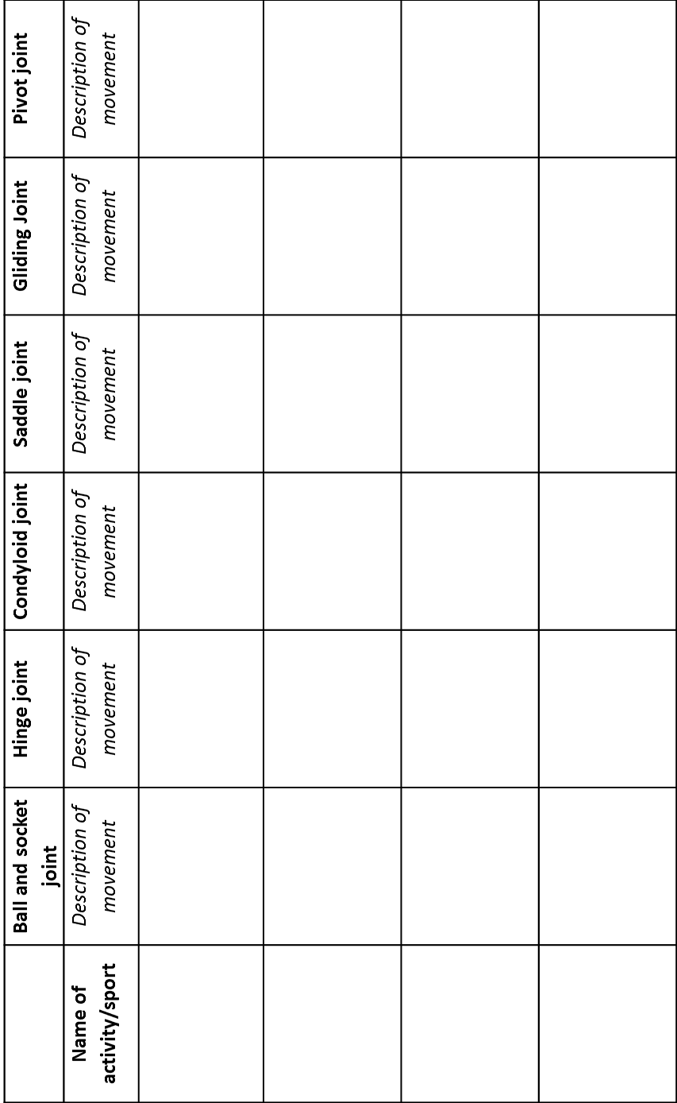

Skipping
Serving a tennis ball
Throwing a baseball
A penalty kick in football

Bone Injuries - webquest
1. STRAINS AND SPRAINS
Go to http://www.hughston.com/hha/a.strain-sprain.htm
What is the difference between a SPRAIN and a STRAIN?

2. ARTHRITIS: TWO TYPES
- Osteoarthritis http://www.medicinenet.com/osteoarthritis/article.htm
  - Description/Cause:

  - What are “bone spurs” and how are they associated with OA?
http://www.mayoclinic.com/health/bone-spurs/DS00627

  - How does this relate to the overload principle?

- Rheumatoid Arthritis
http://www.arthritis.org/about-arthritis/types/rheumatoid-arthritis/
  - Description of rheumatoid arthritis:

  - How does RA differ from OA?

3. BONE FRACTURES: http://www.medicinenet.com/fracture/article.htm
a. Greenstick fracture: (draw and define)

b. Comminuted fracture: (draw and define)

- Compound fracture: (draw and define)

4. WHAT´S UP WITH THE PHRASE ‘DOUBLE-JOINTED? –CAN YOU EXPLAIN WHAT IT MEANS?
http://www.personal.psu.edu/afr3/blogs/SIOW/2010/09/why-are-some-people-double-jointed.html

5. CRACKING YOUR KNUCKLES?… (be sure to visit BOTH sites)
http://www.livescience.com/health/060710_mm_joints_crack.html
http://www.physorg.com/news64162917.html
a. What are the different explanations behind what causes the “popping” sounds associated with joint-popping?

b. Can cracking your knuckles cause arthritis?

