**Muscles Workbook**

**Types of muscles**

**gravity skeletal striated voluntary extend**

**intestines cardiovascular smooth conscious cardiac**

**nonstriated heart veins organs skill**

***Complete*** *the paragraphs below using the terms in the word bank above – words can be used more than once or not at all*

1) ………………………. muscle:

This muscle contracts without ………………………. control. It is found in the walls of our internal………………………. This muscle is positioned in the diaphragm, eyes, blood vessels, stomach,………………………. bladder and in the uterus of females. It is also sometimes called ’……………………….muscle’ because it lacks the stripes which are visible in striated muscle. Another example is when this type of muscle lines the walls of the……………………….to push blood back to the heart from the lower body. This is necessary because the blood has to move against……………………….

2) ………………………. muscle:

This is a special type of………………………. muscle that is found only in the walls of the ……………………….It contracts the heart to pump blood through it. It is different from other involuntary muscles as it contracts rhythmically and never tires. It can be trained like any other muscle which is why we take part in ………………………. exercise.

3) ………………………. muscle:

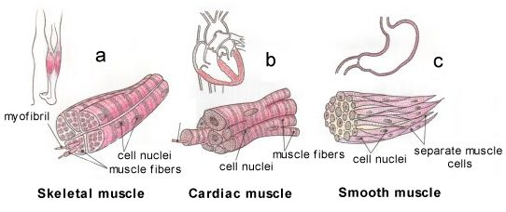 This muscle is found all of the body and is responsible for movement through………………………. thought. When a footballer kicks a ball he is using this type of muscle in order to………………………. the leg and make contact. It is this type of muscle which we use to generate the ………………………. that we use in sport.

**Functions of muscles**

***Outline*** *4 functions of muscles*

1.

2.

3.

4.

**Properties of muscles**

***Describe*** *the following properties of muscles*

|  |  |
| --- | --- |
| contractility |  |
| extensibility |  |
| elasticity |  |

**Investigating The Effects of Temperature on Muscle Function**

Materials:

Ice

Pen or pencil

1. Write your signature 3 times under the column labelled “Normal”.

2. Obtain a handful of ice and hold it in your writing hand (over a sink!)

3. Write your signature 3 times under the column labelled “Cold”.

3. Place your hands under warm running water for a few minutes and massage your hands

4. Write your signature 3 times under the column labelled “Warm”.

|  |  |  |
| --- | --- | --- |
| **Normal** | **Cold** | **Warm** |
|  |  |  |
|  |  |  |
|  |  |  |

Analysis

• What effect did the changes in temperature have on your hand muscles?

• How could you explain this effect?

• Why do you think dancers wear leg warmers and baseball pitchers wear jackets before pitching?

**Origin and Insertion of muscles**

***Complete*** *the paragraph below and* ***annotate*** *the diagram*

When a muscle contracts, only one bone moves leaving the other stationary. The points at which the tendons are attached to the bone are known as the **_________________** and the **_________________.**

* The **origin** is where the tendon of the muscle joins the **_________________** bone(s).
* The **insertion** is where the tendon of the muscle joins the **_________________** bone(s).
* The **_________________** and **_________________** are the moving bones(____________________)
* 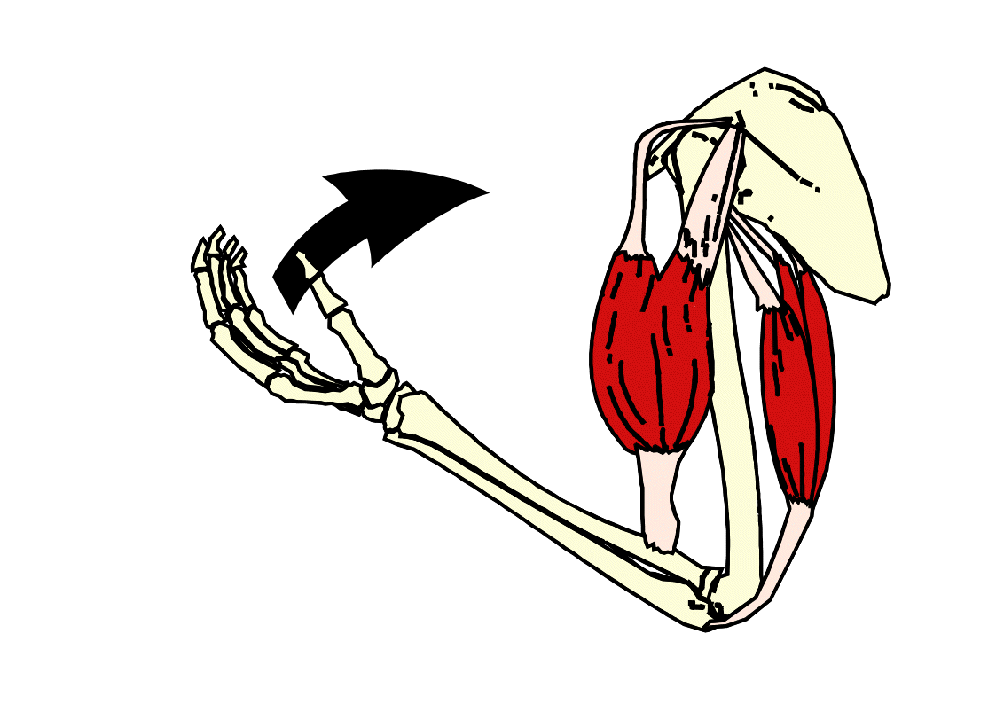The **_________________** and **_________________** are the stationary bones (___________________)

**Muscles of the body**

***Label*** *the diagram below*

**How muscles work**

*Complete the paragraphs below using words from the word bank – you can use them more than once if necessary.*

Muscles work in pairs. As one muscle ………………………., the other ……………………….. to allow movement to take place across the joint.

Muscles have to work in pairs because a ………………………. can only ………………………. on a bone, it can push the bone back to its ………………………. ……………………….- the other muscle is responsible for this.

A good example of this pairing is the ………………………. ………………………. and the ……………………… …………………….. . As the biceps brachii contract, the triceps brachii ………………………. and the elbow joint is ………………………..

Other muscles support the agonist in creating movement and these are called ………………………. (neutraliser). ………………………. (stabiliser) muscles allows the agonist to work, stabilising the origin.

WORD BANK

original position contracts pull relax fixator

biceps brachii synergist relaxes muscle triceps brachii

flexed

**Muscles of the trunk**

|  |  |  |  |  |  |  |  |  |  |
| --- | --- | --- | --- | --- | --- | --- | --- | --- | --- |
| **Muscle** | **Location** | | | **Movement** | | **Origin** | | **Insertion** | **Strengthening exercise** |
|  | http://www.myweightlifting.com/image-files/rectus-abdominis.jpg | | |  | |  | |  |  |
|  | http://www.myweightlifting.com/image-files/external-obliques.jpg | | |  | |  | |  |  |
| **Muscle** | | **Location** | **Movement** | | **Origin** | | **Insertion** | | **Strengthening exercise** |
|  | | http://www.myweightlifting.com/image-files/erector-spinae.jpg |  | |  | |  | |  |

**Muscles of the upper extremity**

|  |  |  |  |  |  |
| --- | --- | --- | --- | --- | --- |
| **Muscle** | **Location** | **Movement** | **Origin** | **Insertion** | **Strengthening exercise** |
|  | https://encrypted-tbn2.gstatic.com/images?q=tbn:ANd9GcQ7WnmvufGScf4EFj4c5dBWZAj3Ol6ths9w-b4JciTkbwXIuWrA |  |  |  |  |
|  | http://www.exrx.net/Images/Muscles/PectoralisSternal.gif |  |  |  |  |
|  | https://encrypted-tbn0.gstatic.com/images?q=tbn:ANd9GcQi34djhg2g0Yffu34b_fZ6iViM7uIHSz4IKz38wKxkqmK17wbiR9JuCzQ |  |  |  |  |

|  |  |  |  |  |  |
| --- | --- | --- | --- | --- | --- |
| **Muscle** | **Location** | **Movement** | **Origin** | **Insertion** | **Strengthening exercise** |
|  | http://traningslara.se/wp-content/uploads/2009/02/tricep.jpg |  |  |  |  |
|  | http://www.myweightlifting.com/image-files/latissimus-dorsi.jpg |  |  |  |  |
|  | https://encrypted-tbn3.gstatic.com/images?q=tbn:ANd9GcSWCuaavlXecCLO6lOkoI0llg5AhBcxd4eubLdIXvYyxYQPUWzy |  |  |  |  |

**Muscles of the lower extremity**

|  |  |  |  |  |  |
| --- | --- | --- | --- | --- | --- |
| **Muscle** | **Location** | **Movement** | **Origin** | **Insertion** | **Strengthening exercise** |
|  | http://adolescenthippain.weebly.com/uploads/1/2/5/6/12564016/9010027_orig.jpg |  |  |  |  |
|  |  |  |  |  |  |
|  | http://1.bp.blogspot.com/_vF3fLRZ8slM/TMOVFJ95PNI/AAAAAAAAADA/uZ7xYm8A-vY/s320/1182141_f260.jpg |  |  |  |  |

|  |  |  |  |  |  |
| --- | --- | --- | --- | --- | --- |
| **Muscle** | **Location** | **Movement** | **Origin** | **Insertion** | **Strengthening exercise** |
|  | http://upload.wikimedia.org/wikipedia/commons/9/91/Gluteus_maximus.png |  |  |  |  |
|  | http://www.exrx.net/Images/Muscles/TibialisAnterior.gif |  |  |  |  |
|  | http://trufitbc.com/wp-content/uploads/2012/06/Hamstring.gif |  |  |  |  |

|  |  |  |  |  |  |
| --- | --- | --- | --- | --- | --- |
| **Muscle** | **Location** | **Movement** | **Origin** | **Insertion** | **Strengthening exercise** |
|  | http://www.rad.washington.edu/academics/academic-sections/msk/muscle-atlas/lower-body/gastrocnemius/atlasImage |  |  |  |  |
|  | http://www.velocityfitnessblog.com/wp-content/uploads/2012/02/soleus1.jpg |  |  |  |  |

**Structure of skeletal muscle**



**Define the following terms:**

**hypertrophy: ______________________________________________________________________________**

**atrophy: ______________________________________________________________________________**

**Skeletal Muscle matching activity**



**Breakdown of a Muscle Fiber**

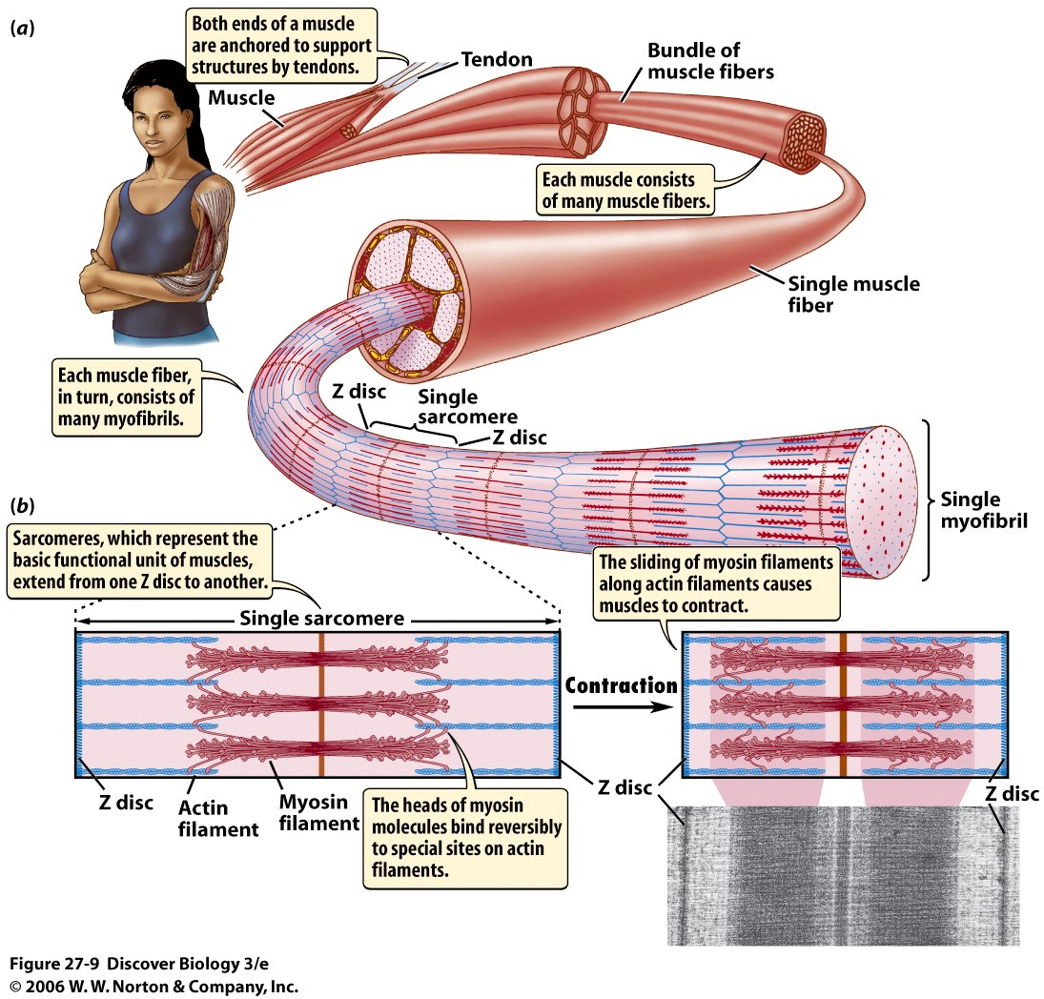

**Group Activity –** Create a flow diagram to show the different levels of skeletal muscle structure.

**Description**