Topic 3: Nutrition and Energy Systems

The Relationship Between Nutrition, Environment and Health
External Environment
Internal Environment
Nutritional Requirements
Nutritional Status
Disease
Health

3.1.1 List the macronutrients and micronutrients
 | Description: | Includes:
Macronutrient
Micronutrient

3.1.2 Outline the functions of macronutrients and micronutrients
Type of Nutrient | Food Source | Functions
Carbohydrate
Fat
Protein
Water
Vitamins
Minerals

3.1.3 State the chemical composition of a glucose molecule
________________________________________________________________________________________________________________________________________________________________________________________________________________________________________________________________________________________________________________________________________________________________________________________________________

3.1.4 Identify a diagram representing the basic structure of a glucose molecule

3.1.5 Explain how glucose molecules can combine to form disaccharides and polysaccharides.

Monosaccharides: ___________________________________________________________________________________
__________________________________________________________________________________________________
Disaccharides: ______________________________________________________________________________________
__________________________________________________________________________________________________
Polysaccharides: ____________________________________________________________________________________
__________________________________________________________________________________________________
What is a Condensation Reaction? ______________________________________________________________________________________________________________________________________________________________________________________________________________________________________________________________________________________________________
Carbohydrates are the most important source of food energy in the world with different food sources available in different countries depending on availability and cultural preferences. Complete the chart below:
Country | Major CHO Source
China
Ireland
Mexico
Nigeria
Italy
Oceania

3.1.6 State the composition of a molecule of triglycerol (triglyceride)
Also known as: _____________________________________________________________________________________
Consists of: ________________________________________________________________________________________
Stored in: __________________________________________________________________________________________

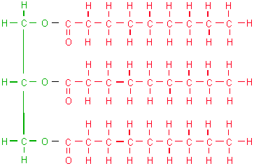

Glycerol 3 Fatty Acid Tails

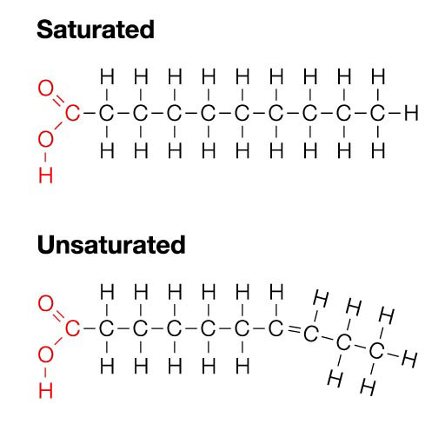
3.1.7 Distinguish between saturated and unsaturated fatty acids

What difference do you notice between the two?
Unsaturated | Saturated
To Do: Read page 54-55 in your textbook. Describe a trans fat. Why is this harmful? Should the government have put a ban on foods with trans fat? Why or why not? Discuss with a partner.
____________________________________________________________________________________________________________________________________________________________________________________________________________________________________________________________________________________________________________________________________________________________________________________________________________________________________________________________________________________________________________________________________________________________________________________________________________________________________________________________________________________________________________________________________________________________________________________________________________________________________________________________________________________________________________________________________________________________________________________________________________________

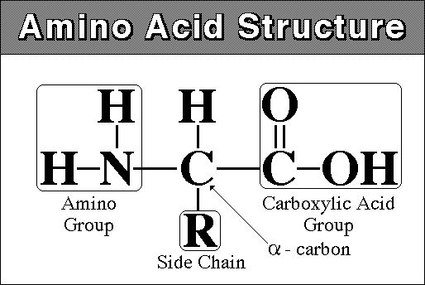
3.1.8 State the chemical composition of a protein molecule
The base elements of proteins are:

The most basic units of proteins are 20 different amino acids. Each are characterized by the same central structure and a side chain (“R”) that determines the physical and chemical properties.

3.1.9 Distinguish between an essential and non-essential amino acid.
_______________________ Amino Acids: cannot be manufactured by the body and must be obtained through diet.
- There are 9 essential amino acids, the best sources of these are meat, fish, fowl, eggs and dairy products.
- Individual sources of protein are considered complete if they supply all 9 essential amino acids.
_______________________ Amino Acids: can be synthesized by the body.

3.1.11 State the approximate energy content per 100g of carb, lipid and protein
Lipid:
Carbohydrate:
Protein:
What do you notice about the calorie densities of various energy sources? _____________________________________ ____________________________________________________________________________________________________________________________________________________________________________________________________
Protein-Energy Malnutrition: Read Protein-Energy Malnutrition in Children from page 57 in your textbook and answer the 3 questions at the end of the case study.

Micronutrients
Complete the following table with regards to vitamins and minerals.
 | Description | Role in the Body | Classifications | Examples
Vitamins
Minerals

List the 6 Important functions of water within the human body:
- ___________________________________________________________________________________________
- ___________________________________________________________________________________________
- ___________________________________________________________________________________________
- ___________________________________________________________________________________________
- ___________________________________________________________________________________________
- ___________________________________________________________________________________________

3.1.10 Describe the current recommendations for a healthy, balanced diet
The government of Canada distributes 5 user-friendly, general statements to consider when choosing what to eat:
- ___________________________________________________________________________________________
- ___________________________________________________________________________________________
- ___________________________________________________________________________________________
- ___________________________________________________________________________________________
- ___________________________________________________________________________________________
Canada’s Food Guide to Healthy Eating translates nutrient recommendations into a food group based plan to ensure a balanced intake of essential nutrients. Fill in the food guide table with the recommendations for your age and gender:
Food Group | Servings per Day | Examples of 1 food guide serving | Directional statement(s)
Vegetables and Fruits
Grain Products
Milk Products
Meat and Alternatives

3.1.12 Discuss how the recommended energy distribution of the dietary macronutrients differs between endurance athletes and non-athletes
Summarize the article. Be sure to reference to how macronutrient recommendations (carbohydrates, fat, and protein) differ between endurance athletes and non-athletes. Why are they needed in different amounts?

