Option D: Nutrition for Sport and Exercise

D.1.1 Outline the features of the principle components of the digestive system.
Fill in the table below using information from your slides and textbook Ch. 16.
Digestive Component | Function | Key Features
Mouth (example) | Mechanical digestion of food occurs through chewing. Saliva aids in chemical digestion of food and coats the ground food, called a bolus, in mucous to make it easier to swallow. | Mechanical and chemical  Ground food = bolus
Esophagus
Stomach
Small Intestine
Liver and Gall Bladder
Pancreas
Large Intestine
Digestive Enzymes

Label the following structures on the diagram below:

- Mouth
- Large Intestines
- Stomach
- Esophagus

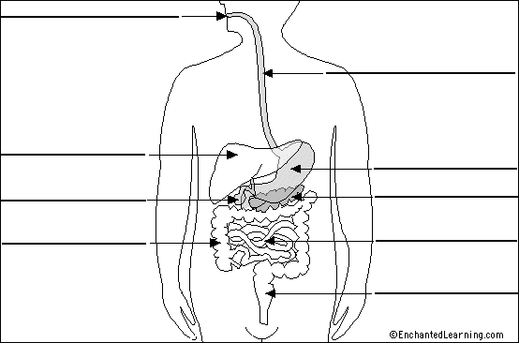
Pancreas
- Small Intestines
- Liver
- Rectum

D.1.2 State the typical pH values found throughout the digestive system.
Using your textbook, pg. 315, add the typical pH values for the mouth, stomach and small intestines to your diagram above. In the space below describe the relationship between the function of digestive enzymes and pH.
__________________________________________________________________________________________________ __________________________________________________________________________________________________
__________________________________________________________________________________________________ __________________________________________________________________________________________________
__________________________________________________________________________________________________ __________________________________________________________________________________________________
__________________________________________________________________________________________________ __________________________________________________________________________________________________

D.1.3 – D.1.5 Function and importance of digestive enzymes
Use your notes and textbook pages 314-315 to answer the following questions.
- Explain how enzymes aid in the digestion of macronutrients. How do they affect digestive reactions? What 3 things influence the action of enzymes?

- Why do we need enzymes for digestion?

- List the enzymes that are responsible for the digestion of:
  - Carbohydrates

  - Fats

  - Protein

D.1.6 Describe the absorption of glucose, amino acids and fatty acids from the intestinal lumen to the capillary network.
Describe the difference between the absorption of glucose and amino acids and the absorption of fatty acids.
__________________________________________________________________________________________________
__________________________________________________________________________________________________ __________________________________________________________________________________________________
__________________________________________________________________________________________________ __________________________________________________________________________________________________
Use a flow chart to summarize the process of absorption and assimilation of macronutrients through the different components of the digestive system.

MOUTH STOMACH SMALL INTESTINE LARGE INTESTINE

D.2.1 State the reasons why humans cannot live without water.
List 4 reasons humans cannot survive prolonged periods of time without water.
- __________________________________________________________________________________________ __________________________________________________________________________________________
- __________________________________________________________________________________________ __________________________________________________________________________________________
- __________________________________________________________________________________________ __________________________________________________________________________________________
- __________________________________________________________________________________________ __________________________________________________________________________________________
Ways we absorb water into the body | Ways water is lost from the body

D.2.2 State where extracellular fluid can be located throughout the body.
Intracellular (ICF) and extracellular (ECF) fluids make up a combined 50-70% of total body mass. ICF is contained within cells but extracellular fluid has several locations throughout the body. List the 6 locations ECF can be found.
- _____________________________________________________________________
- _____________________________________________________________________
- _____________________________________________________________________
- _____________________________________________________________________
- _____________________________________________________________________
- _____________________________________________________________________

D.2.3 Compare water distribution in trained and untrained individuals.
Water makes up approximately 60-70% of body weight in people with a normal, healthy body composition. Explain why this number might be higher in athletes and lower in overweight people.
________________________________________________________________________________________________________________________________________________________________________________________________________________________________________________________________________________________________________________________________________________________________________________________________________

D.2.4 Annotate a diagram of a glomerulus and associated nephron.
Label the following on the diagrams below:

- Renal artery
- Renal vein
- Ureter
- Nephron
- Glomerulus
- Bowman’s capsule
- Proximal convoluted tubule
- Loop of Henle
- Distal convoluted tubule
- Peritubular capillaries
- Collecting duct

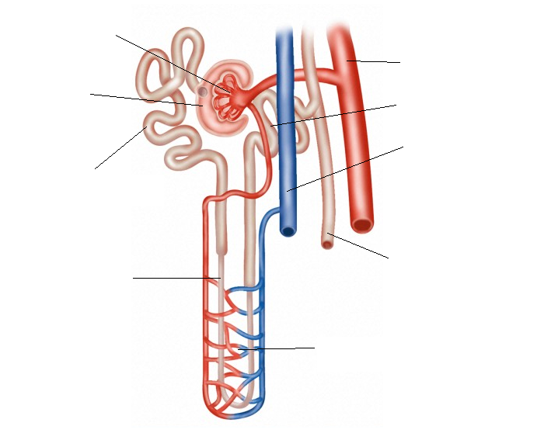

D.2.5 Explain that homeostasis involves monitoring levels of variables and correcting changes in levels by negative feedback mechanisms.
Explain how negative feedback mechanisms work to keep the body hydrated. In your explanation include the terms stimulus, response, thirst, and anti-diuretic hormone (ADH).
________________________________________________________________________________________________________________________________________________________________________________________________________________________________________________________________________________________________________________________________________________________________________________________________________
____________________________________________________________________________________________________________________________________________________________________________________________________

D.2.6 Explain the roles of the loop of Henle, medulla, collecting duct and ADH in maintaining the water balance of blood.
Annotate the diagram below explaining how the kidney controls the retention and loss of water.

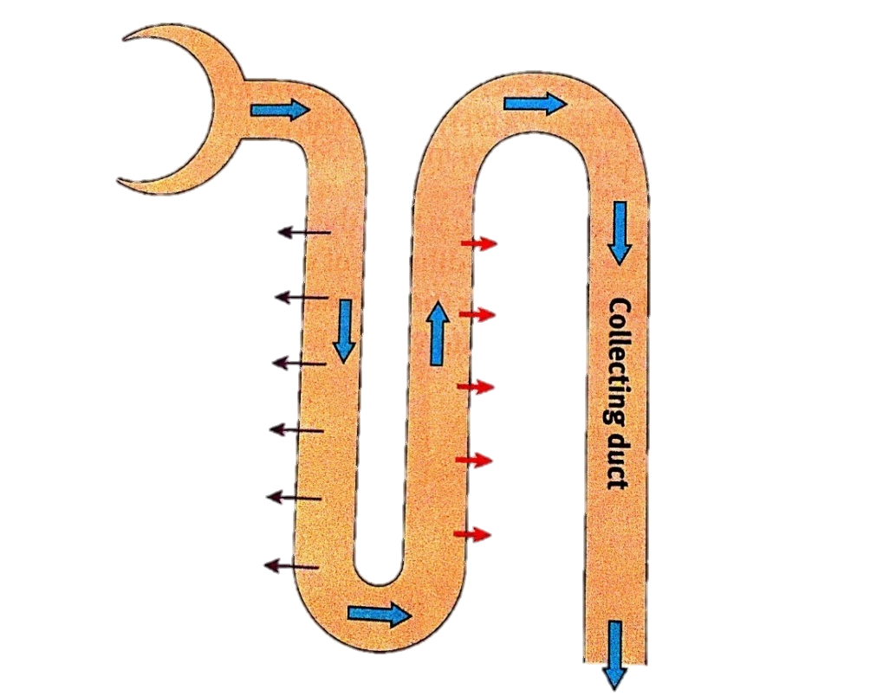
Glomerulus

Medulla

Loop of Henle

D.2.7 Describe how the hydration status of athletes can be monitored.
Using your textbook pages 320 – 321 briefly explain each of the following methods of monitoring hydration status.
- Urine Colour

- Urine Osmolarity

- Variation in Body Mass Loss

