**CARDIO-RESPIRATORY EXERCISE PHYSIOLOGY WORKBOOK**

# The Ventilatory System

*Can you label the parts of the ventilator system below?*

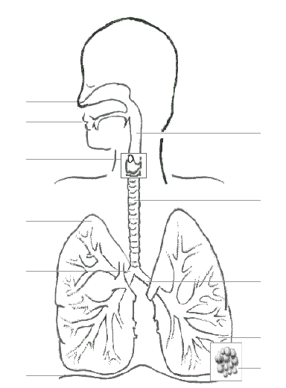

## Functions of the Ventilatory System

*Complete the table below. Be sure to include complete terms and definitions.*

|  |  |  |
| --- | --- | --- |
| **Structure** | **Function** | |
| Nose and Mouth |  | |
| Pharynx |  | |
| Larynx (voice box) |  | |
| Trachea |  | |
| Bronchi | |  |
| Bronchioles | |  |
| Lungs | |  |
| Alveoli | |  |

## Structural Components of the Trachea

**Smooth Muscle**

* _________________ and ________________ to allow the diameter of airways to be controlled.
* Relaxes during _________________ making the airways __________________ and reducing ___________________ to air flow.
* Contracts to narrow the airways when challenged with __________________ to protect alveoli.

**Cartilage**

* Provide ________________________ and prevents the collapse of airway during inhalation.
* Allows ______________________ during movement without narrowing airway.
* Allows the oesophagus to expand during __________________________.

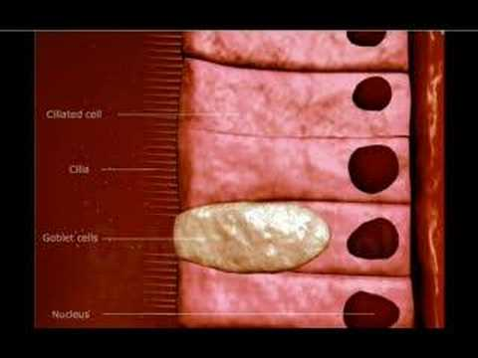**Elastic Fibres**

* Stretch to allow _______________________ during ______________________ and recoil during exhalation to prevent over expansion and to _________________________ when exhaling.

**Epithelial Lining**

* **Goblet Cells** 
  + Secrete _________________ which traps foreign particles like dust and bacteria (reduces the risk of infection and inflammation).
* **Celia** 
  + Hair-like structures which move mucus towards throat to be _________________ or _______________________, preventing infection due to bacteria.

## The Pathway of Air

*Fill in the flow chart to illustrate the pathway of air through the structures of the ventilatory system.*

# Mechanics of Ventilation

Breathing is an involuntary process controlled by the ***medulla oblongata*** found in the brainstem of the Central Nervous System (CNS)

The ***ribcage***, ***intercostals*** muscles and ***diaphragm*** all work together to move air into and out of the lungs, where gas exchange occurs across the thin (single-celled) walls of the alveoli.

**Boyle’s Law**

The lungs are constantly trying to keep the body in a state of homeostasis by breathing oxygen in and breathing carbon dioxide out through a process called diffusion.

***Diffusion*:** Gas will move along a gradient from an area of high pressure to low pressure.

## Breathing at Rest

*Use the statements given to annotate the diagram below.*

|  |  |
| --- | --- |
| **Breathing “in”** | **Breathing “out”** |
| 1. Diaphragm contracts and attempts to flatten 2. Lungs are stretched 3. External intercostals pull ribcage to increase the cavity further 4. As volume increases, pressure decreases 5. Air comes into the chest cavity until air pressure is equalized. | 1. Diaphragm relaxes, returning to dome shape 2. External intercostals relax, pushing ribs back to normal position 3. Volume of chest cavity decreases 4. Air pressure in lungs increases and air is forced out. |

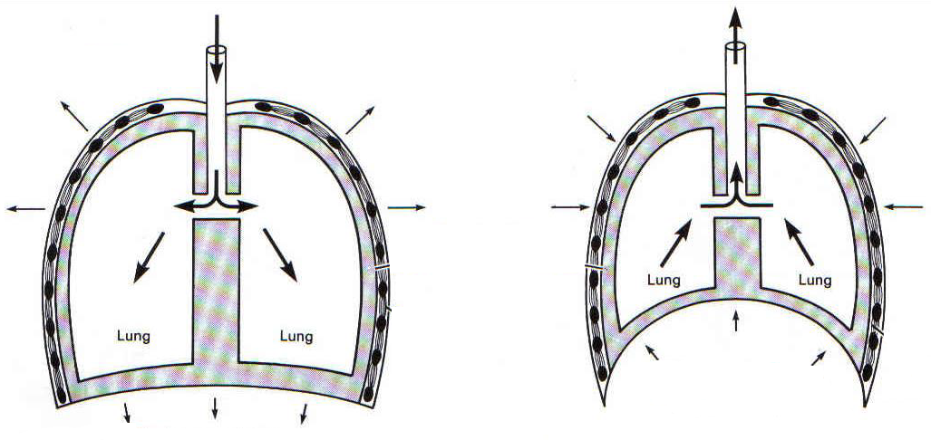

## Summary of Ventilation Mechanics

|  |  |  |
| --- | --- | --- |
|  | Inspiration (inhaling) | Expiration (exhaling) |
| Volume of Thorax |  |  |
| Diaphragm Muscle |  |  |
| Movement of Diaphragm |  |  |
| External Intercostal Muscles |  |  |
| Rib Cage Movement |  |  |
| Pressure in Chest Cavity |  |  |
| Movement of Air |  |  |

# Measuring Lung Volumes and Capacity

*Read the green box on page 34 and define the following terms in your own words.*

|  |  |
| --- | --- |
| **Key Term** | **Definition** |
| Pulmonary Ventilation |  |
| Total Lung Capacity |  |
| Vital Capacity |  |
| Tidal Volume |  |
| Expiratory Reserve Volume (ERV) |  |
| Inspiratory Reserve Volume (IRV) |  |
| Residual Volume (RV) |  |

## Measurement

A _______________________ is a device that measures the volume of gas entering or leaving the mouth. It measures changes in ____________________________ including subdivisions of ______________________________ but does NOT measure ______________________________.



## Breathing During Exercise (p. 35)

When the body needs a greater supply of oxygen, as during exercise, more muscles are required to help with ventilation. This effects ***minute ventilation*** (the volume of air exhaled per minute). Complete the table on page 35 of your textbook using the following equation.

**VE = VT x Bf**

VE – minute ventilation

VT – tidal volume

Bf – breathing frequency

# Nervous and Chemical Regulators of Breathing

*Fill in the blanks of this description of the chemical regulation of breathing using the following terms.*

* **pH** – measure of blood acidity levels
* **pCO₂** – measure of carbon dioxide in blood
* **pO₂** – measure of oxygen levels in blood
* **Central Chemoreceptors** – found in the Medulla Oblongata that detects changes in pH and CO₂ levels
* **Peripheral Chemoreceptors** – found throughout the body, detect changes in pH and CO₂ levels

Changes in blood acidity level (_____) are detected by _______________________ and that signal is sent to the _________________________ in the Medulla Oblongata. This signals an increase in breathing rate and depth as a direct result of the increases in ________ and _________. The main regulator of breathing is _________ which is produced as a waste product during aerobic activity.

# Gas Exchange

*Label the diagram. Then use the word bank to explain the process of gas exchange at the alveoli.* ***Hint:*** *start with deoxygenated blood flowing towards the lung and end with oxygenated blood leaving the lungs.*

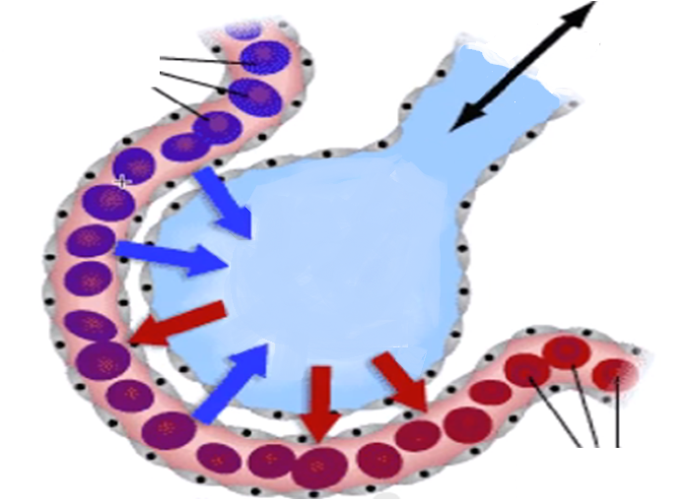Word Bank:

Oxygenated Low concentration Oxygen

Deoxygenated Diffusion One cell thick

High concentration Carbon dioxide

## The Role of Hemoglobin

*Label the diagram and fill in the blanks to annotate.*

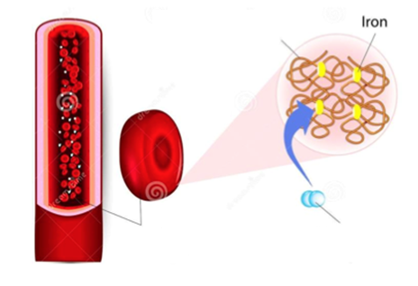Haemoglobin is a protein found in red blood cells.

These are the molecules responsible for transporting 98.5% of the oxygen found in blood.

Iron molecules in the hemoglobin are the site for oxygen binding.